**Web Designing Assignment**

**MODULE: 5 (JQuery Basic, Effects & Advance)**

**Q.1) What is jQuery?**

**Ans:** jQuery is a fast, small, and feature-rich JavaScript library. It makes things like HTML document traversal and manipulation, event handling, animation, and Ajax much simpler with an easy-to-use API that works across a multitude of browsers. With a combination of versatility and extensibility, jQuery has changed the way that millions of people write JavaScript.

---------------------------------------------------------------------------------------------------

**Q.2) How to Apply CSS Using JQuery, How to Add Class and Remove Class in Jquery , JQuery Animation?**

**Ans: Apply CSS Using JQuery:**

<!DOCTYPE html>

<html lang="en">

<head>

<meta charset="UTF-8">

<meta name="viewport" content="width=device-width, initial-scale=1.0">

<script src="https://cdnjs.cloudflare.com/ajax/libs/jquery/3.7.0/jquery.min.js"></script>

<title>Document</title>

</head>

<body>

<div>s.fk</div>

<script>

$(document).ready(function () {

$("div").css({ "background-color": "red", "font-size": "50px" })

})

</script>

</body>

</html>

**Output:**



**Add Class:**

<!DOCTYPE html>

<html lang="en">

<head>

<meta charset="UTF-8">

<meta name="viewport" content="width=device-width, initial-scale=1.0">

<title>Document</title>

<script src="https://cdnjs.cloudflare.com/ajax/libs/jquery/3.7.0/jquery.min.js"></script>

<style>

.one{

height: 100px;

width: 100px;

border: 2px solid black;

}

</style>

</head>

<body>

<div></div>

<button>xyz</button>

<script>

$(document).ready(function () {

$("button").click(function () {

$("div").addClass("one")

})

})

</script>

</body>

</html>

**Output:**

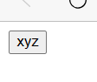

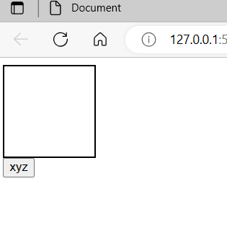

**Remove Class:**

<!DOCTYPE html>

<html lang="en">

<head>

<meta charset="UTF-8">

<meta name="viewport" content="width=device-width, initial-scale=1.0">

<title>Document</title>

<script src="https://cdnjs.cloudflare.com/ajax/libs/jquery/3.7.0/jquery.min.js"></script>

<style>

.one{

height: 100px;

width: 100px;

border: 2px solid black;

}

</style>

</head>

<body>

<div class="one"></div>

<button>xyz</button>

<script>

$(document).ready(function () {

$("button").click(function () {

$("div").toggleClass("one")

})

})

</script>

</body>

</html>

**Output:**





**Jquery Animation:**

<!DOCTYPE html>

<html lang="en">

<head>

<meta charset="UTF-8">

<meta http-equiv="X-UA-Compatible" content="IE=edge">

<meta name="viewport" content="width=device-width, initial-scale=1.0">

<title>Document</title>

<script src="https://cdnjs.cloudflare.com/ajax/libs/jquery/3.7.0/jquery.min.js"></script>

<style>

div{

height:500px;

width: 300px;

background-color: aqua;

position: relative;

}

</style>

</head>

<body>

<div id="one">1</div>

<button>abc</button>

<script>

$(document).ready(function () {

$("button").click(function () {

$("div").animate({"left": "20%"})

$("div").animate({"fontSize": "300px"})

// $("div").animate({"width": "toggle"})

})

})

</script>

</body>

</html>

**Output:**

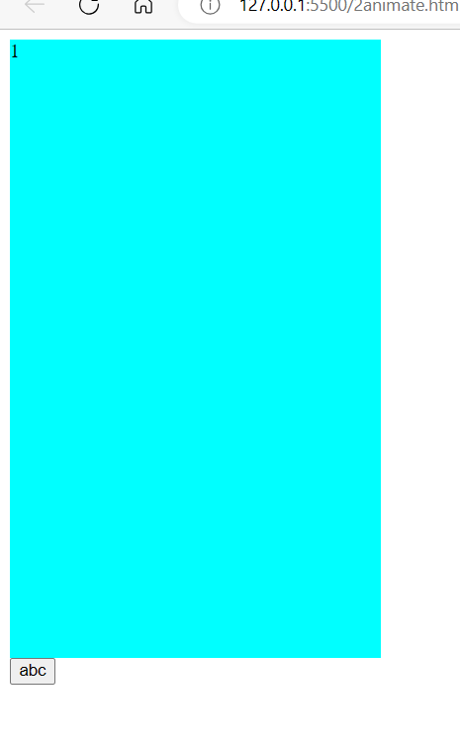

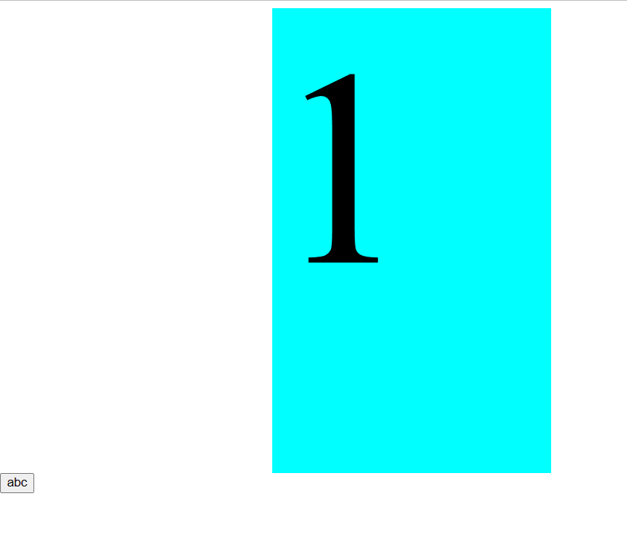

---------------------------------------------------------------------------------------------------

**Q.3) How to create slider with animation?**

**Ans:** <!DOCTYPE html>

<html lang="en">

<head>

<meta charset="UTF-8">

<meta name="viewport" content="width=device-width, initial-scale=1.0">

<title>Document</title>

<script src="https://cdnjs.cloudflare.com/ajax/libs/jquery/3.7.0/jquery.min.js"></script>

<style>

div{

height: 250px;

background-color: aqua;

}

#one-2{

display: none;

}

</style>

</head>

<body>

<button>xyz</button>

<div id="one-1">1</div>

<div id="one-2">2</div>

<script>

$(document).ready(function () {

$("#one-1").click(function() {

$("#one-2").slideToggle(3000)

})

$("button").click(function () {

$("#one-2").stop()

})

})

</script>

</body>

</html>

**Output:**

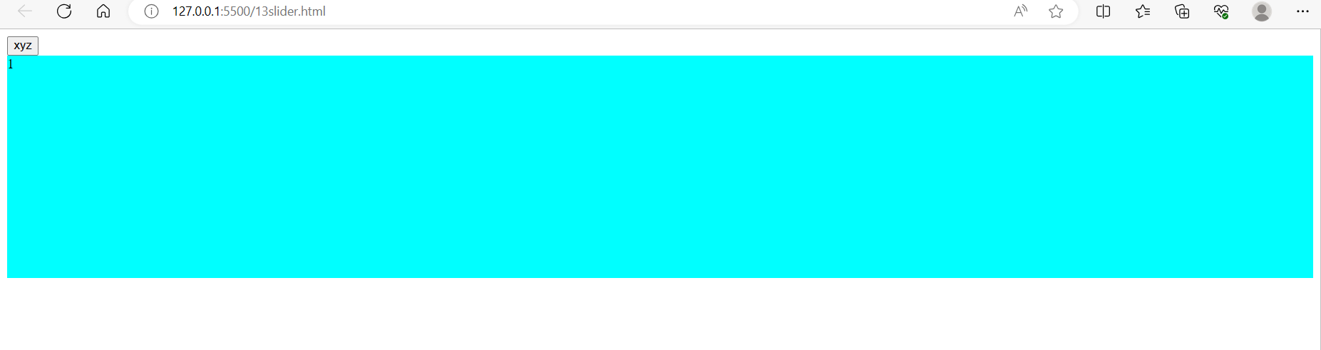

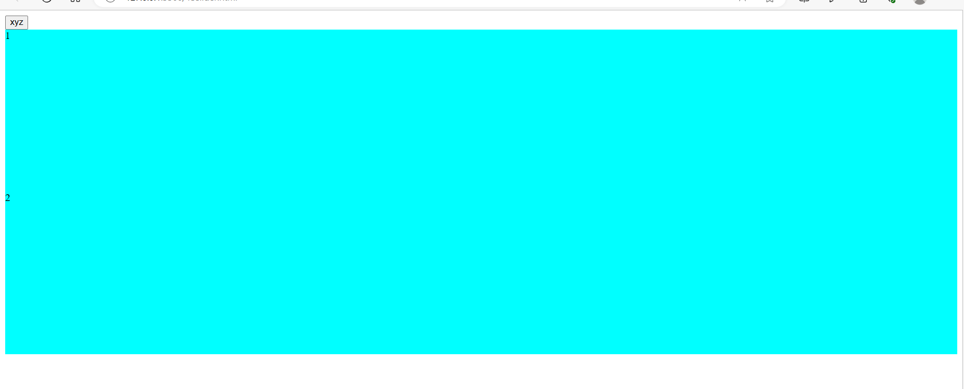

---------------------------------------------------------------------------------------------------

**Q.4) Event bubbling tickling example?**

**Ans:Example:**

<!DOCTYPE html>

<html lang="en">

<head>

<meta charset="UTF-8">

<meta name="viewport" content="width=device-width, initial-scale=1.0">

<script src="https://cdnjs.cloudflare.com/ajax/libs/jquery/3.7.0/jquery.min.js"></script>

<title>Document</title>

<style>

body * {

border: 2px solid black;

padding: 20px;

display: inline-block;

}

</style>

</head>

<body>

<div>grand father

<ul>father

<li>child

<span>span</span>

</li>

</ul>

</div>

<script>

$(document).ready(function () {

$("span").parentsUntil("div").css({ "border": "2px solid red" })

})

</script>

</body>

</html>

**Output:**

